**Class Test 05**

**PL/SQL**

*To solve the following use the scott schema*

1. Create a cursor that can output all the data from salgrade table.

DECLARE

total_rows NUMBER(2);

CURSOR c_salgrade IS SELECT * FROM salgrade;

r_salgrade c_salgrade%ROWTYPE;

BEGIN

OPEN c_salgrade;

LOOP

FETCH c_salgrade INTO r_salgrade;

EXIT WHEN c_salgrade%NOTFOUND;

DBMS_OUTPUT.PUT_LINE(

'Grade: ' || r_salgrade.grade ||

' | Low: ' || r_salgrade.losal ||

' | High: ' || r_salgrade.hisal

);

END LOOP;

END;

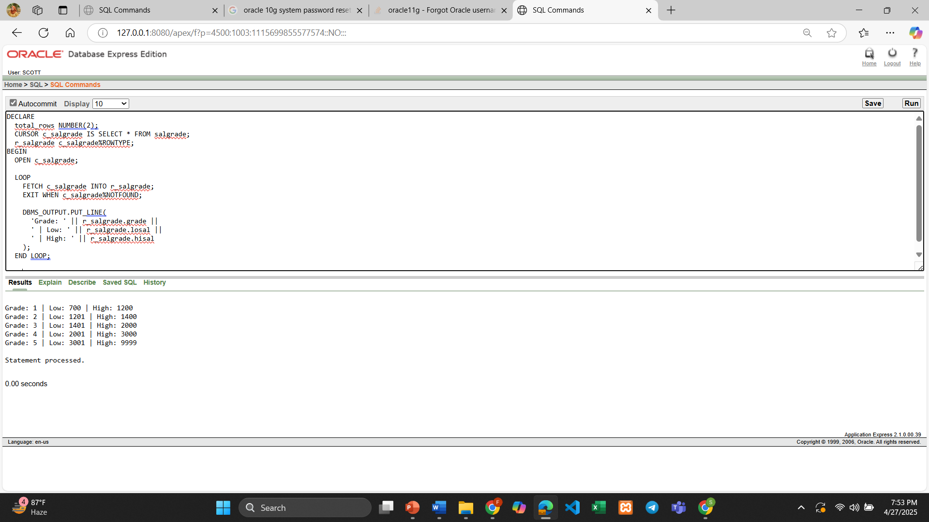

1. Create a record that can output the id, name, job, and hiredate of the employee whose Id is 7654.

DECLARE

emp_rec EMP%ROWTYPE;

BEGIN

SELECT * INTO emp_rec

FROM EMP

WHERE EMPNO = 7654;

DBMS_OUTPUT.PUT_LINE('ID: ' || emp_rec.EMPNO);

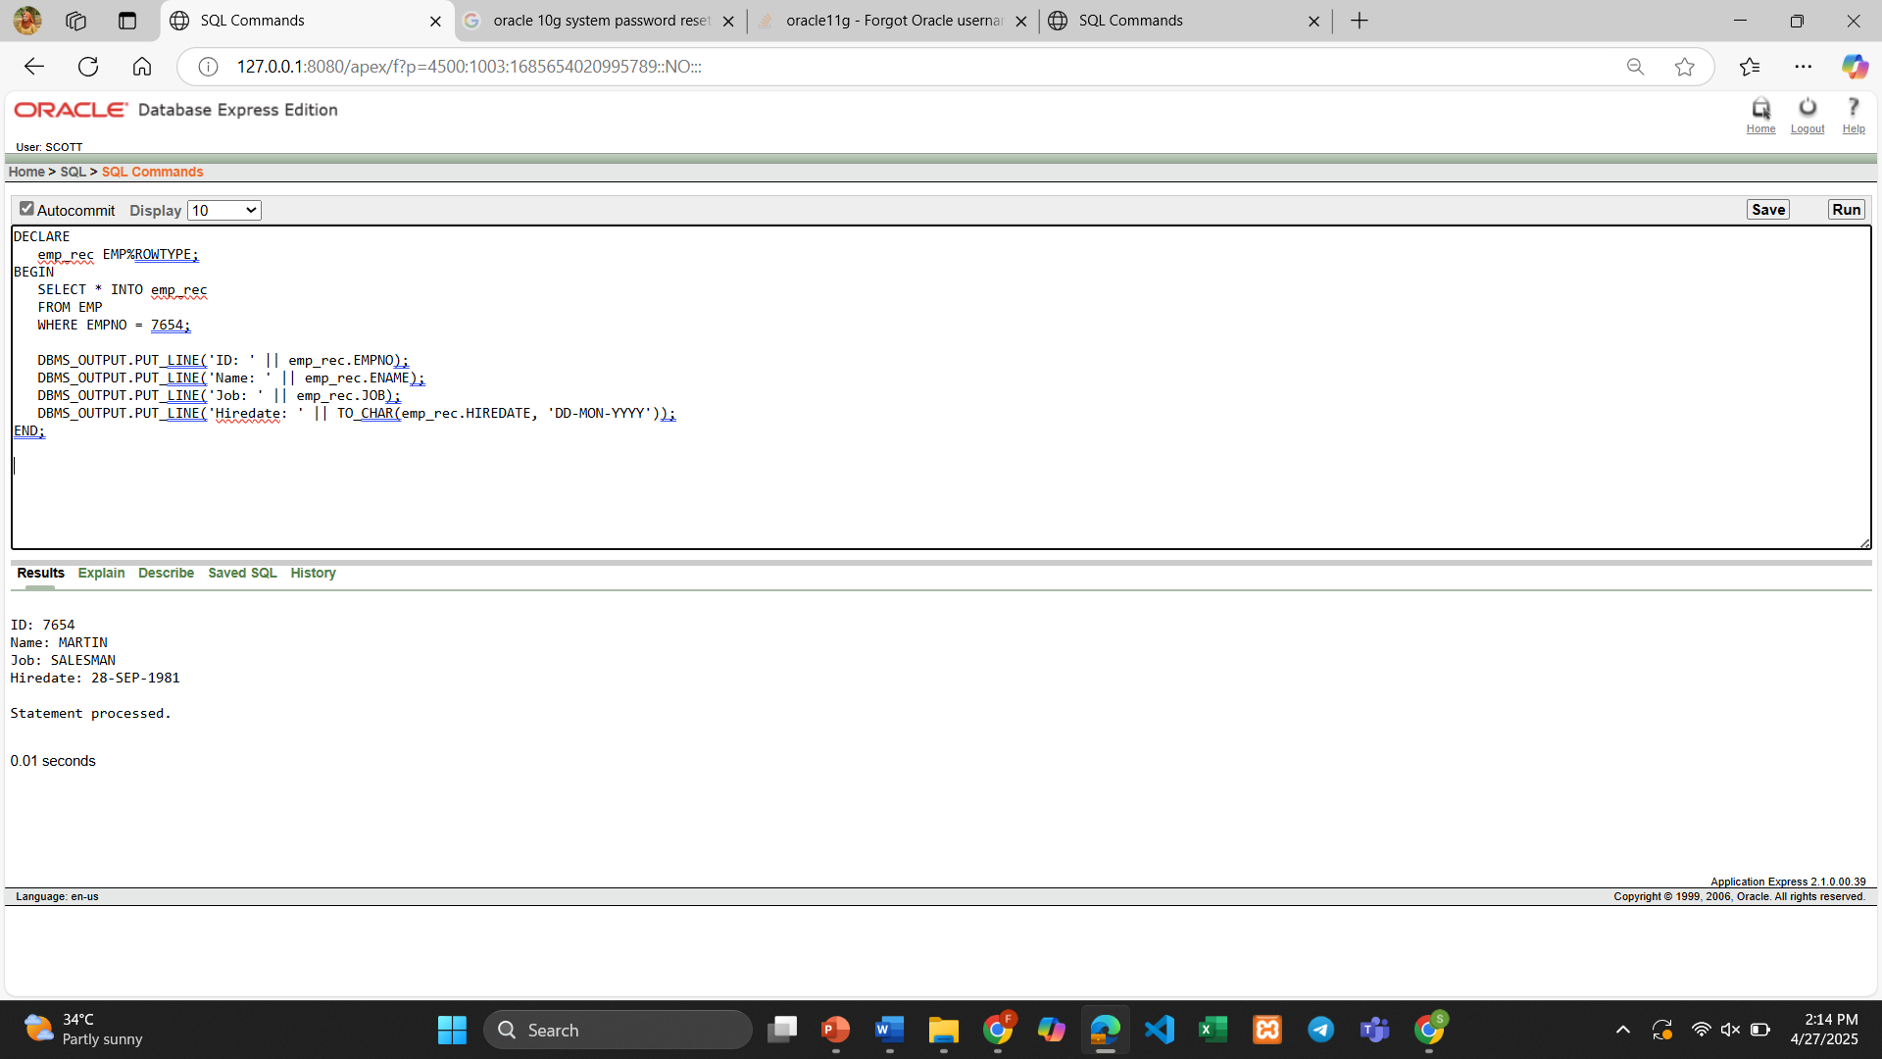

DBMS_OUTPUT.PUT_LINE('Job: ' || emp_rec.JOB);

DBMS_OUTPUT.PUT_LINE('Hiredate: ' || TO_CHAR(emp_rec.HIREDATE, 'DD-MON-YYYY'));

END;

1. Create a trigger in such a way that whenever a new row is inserted into the salgrade table an output ‘New Row Added’ is generated.

CREATE OR REPLACE TRIGGER salgrade_added

AFTER INSERT ON salgrade

FOR EACH ROW

BEGIN

dbms_output.put_line('New Row Added');

END;

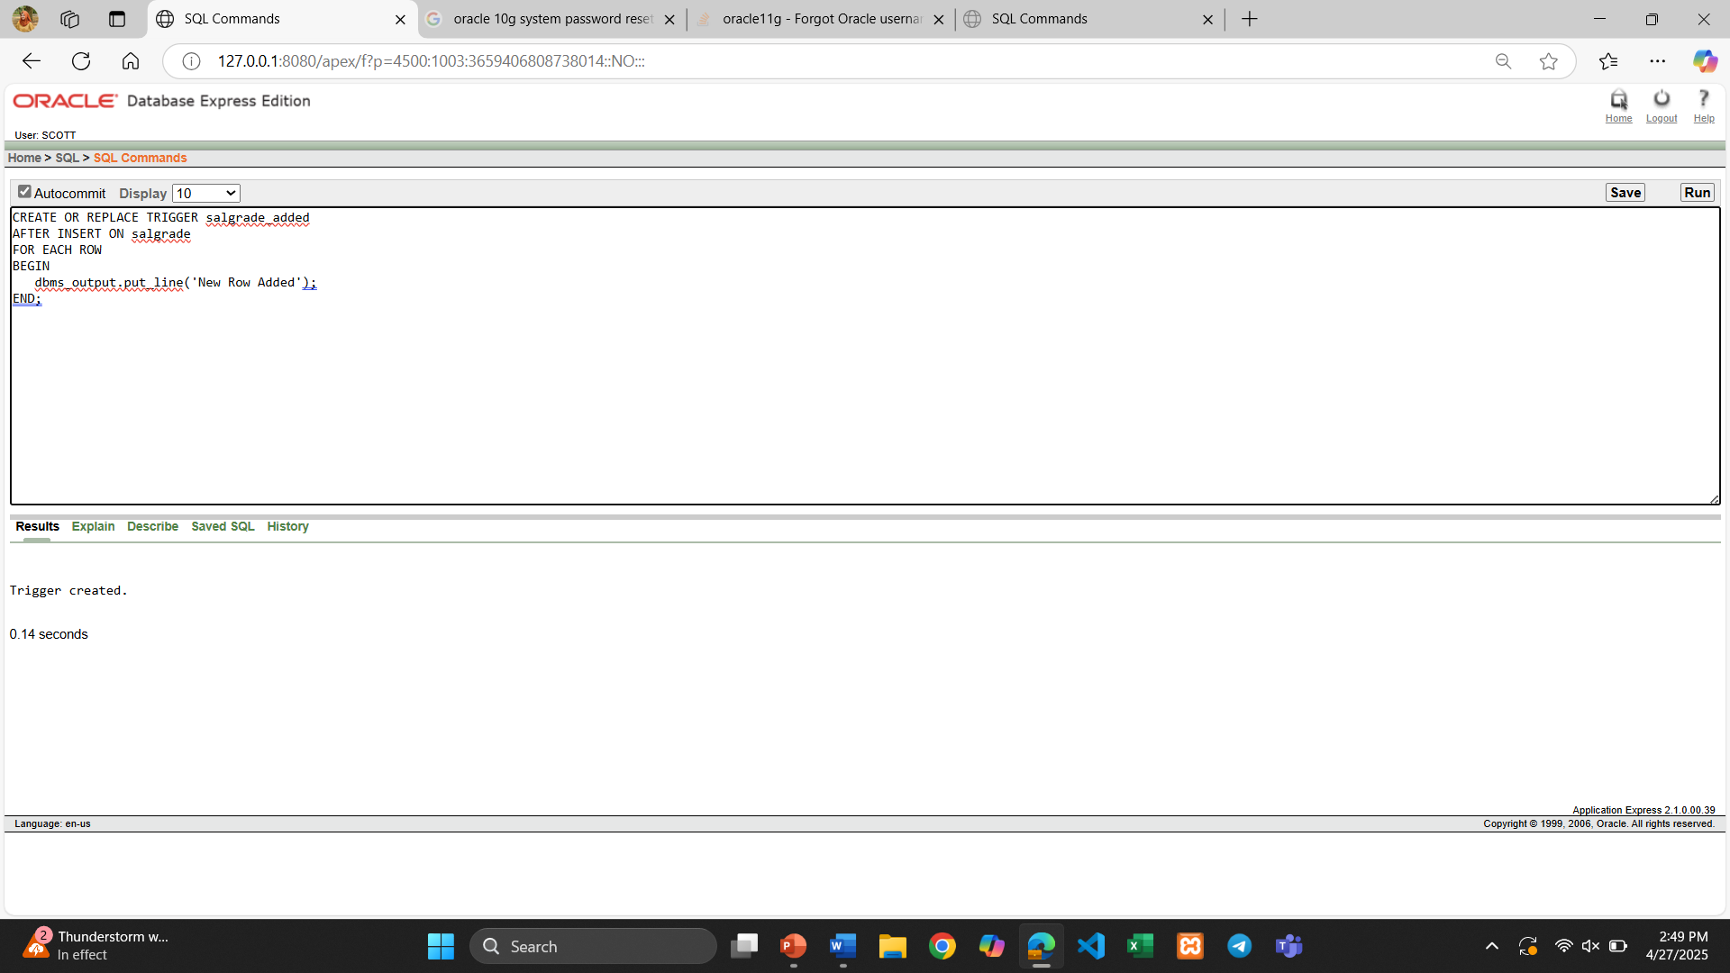

1. Create a package that contains a procedure which can display the grade whose losal and hisal is passed as its parameter.

CREATE OR REPLACE PACKAGE salgrade_pkg AS

PROCEDURE show_grade(p_losal NUMBER, p_hisal NUMBER);

END salgrade_pkg;

CREATE OR REPLACE PACKAGE BODY salgrade_pkg AS

PROCEDURE show_grade(p_losal NUMBER, p_hisal NUMBER) IS

matched_grade NUMBER;

BEGIN

SELECT grade INTO matched_grade

FROM salgrade

WHERE losal = p_losal AND hisal = p_hisal;

DBMS_OUTPUT.PUT_LINE('Grade: ' || matched_grade);

EXCEPTION

WHEN NO_DATA_FOUND THEN

DBMS_OUTPUT.PUT_LINE('No matching grade found.');

WHEN TOO_MANY_ROWS THEN

DBMS_OUTPUT.PUT_LINE('Multiple grades found for the given losal and hisal.');

END show_grade;

END salgrade_pkg;

BEGIN

salgrade_pkg.show_grade(700, 1200);

END;

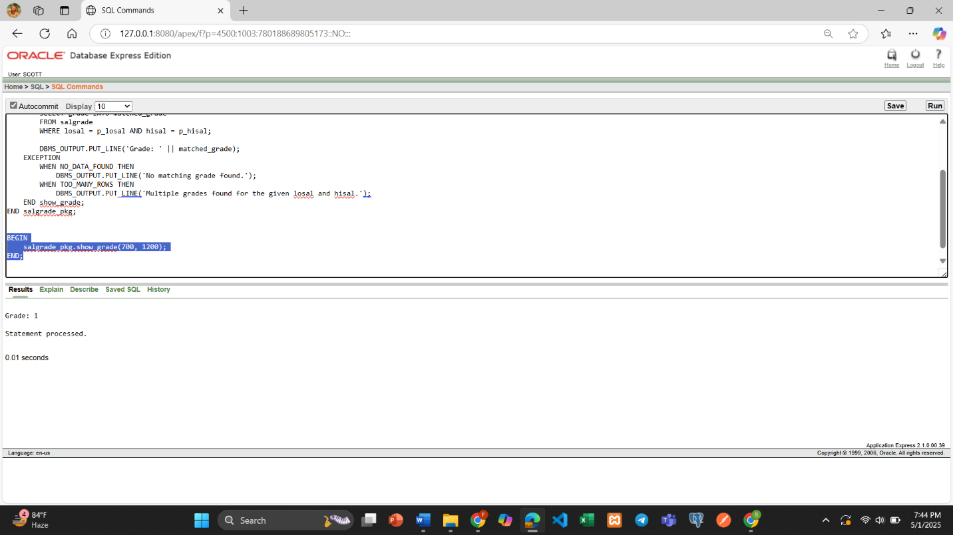

**\*\*After solving the above questions using Oracle 10g, write the PL/SQLs in a MS Word document (Write down the answer and give screenshot of the result of the query. The name of the document MUST be your ID and the PL/SQLs MUST be numbered accordingly) and upload it in the provided link in your VUES account**